**Homework**

State Diagram

Ngô Văn Phóng – 19520834

# State Diagram for Traffic Light

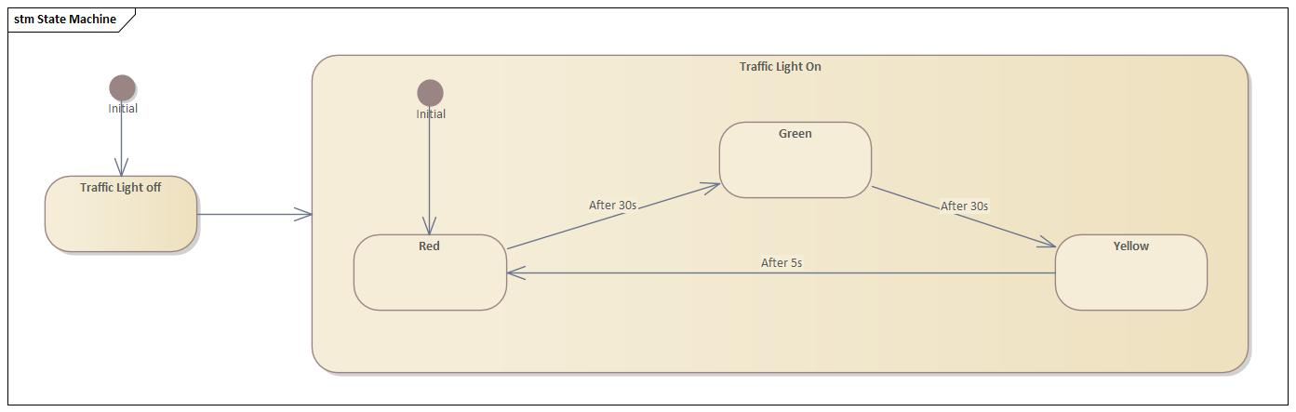

# State Diagram For Book In A Hotel

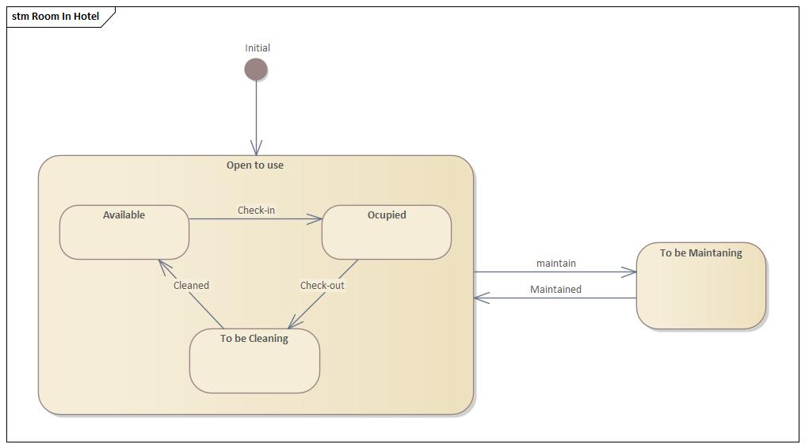

# Elevator

